EXP:6
Preemptive Priority Scheduling
Note: Lower priority number means higher priority.
CODE:
#include <stdio.h>
int main(void) {
int at[] = {
0, 1, 2
}, bt[] = {
4, 3, 1
}, pr[] = {
2, 1, 3
}, rem[] = {
4, 3, 1
}, ct[3] = {
0
}, t = 0, done = 0, i, best;
while (done < 3) {
best = - 1;
for (i = 0; i < 3; i++)
if (at[i] <= t && rem[i] > 0 && (best < 0 || pr[i] < pr[best]))best = i;
if (best < 0) {
t++;
continue;
}
rem[best]--;
t++;
if (rem[best] == 0) {
ct[best] = t;
done++;
}
}
puts("Process Completion Turnaround Waiting");
for (i = 0; i < 3; i++)
printf("P%d %d %d %d\n", i + 1, ct[i], ct[i] - at[i], ct[i] - at[i] - bt[i]);
return 0;
}
OUTPUT:
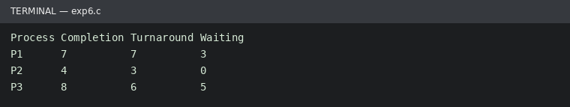
Run status: Ran successfully

